Extra Credit

Ziqi Liu

Question:

A dessert store had five employees. Each employee must be assigned to work on a time series per week There have six time series per day, including 11:30am, 12:00pm,1:30pm,2:00pm,3:00pm and 5:00pm. Each employee must choose three specific time to work. Each employee has ranked the six periods during which they choose. As shown in the file below. A ranking of 10 means that the employee wants to work at that time, and a ranking 1 means that means she does not want to work at that time. Determine an assignment of employee to work that maximizes the total satisfaction of the employee.

|  |  |  |  |  |  |  |
| --- | --- | --- | --- | --- | --- | --- |
| Preferences | 11:30pm | 12:00pm | 1:30pm | 2:00pm | 3:00pm | 5:00pm |
| Employee1 | 3 | 5 | 9 | 9 | 8 | 8 |
| Employee2 | 5 | 4 | 5 | 6 | 4 | 5 |
| Employee3 | 5 | 8 | 8 | 4 | 4 | 9 |
| Employee4 | 7 | 6 | 8 | 7 | 8 | 9 |
| Employee5 | 9 | 8 | 9 | 8 | 8 | 9 |

Discussion:

Each professor ranked their slots and we must assign each section to employee in such a way that we meet our objective which is maximizing the total satisfaction level of the employee. So, our decision variable will be (binary) whether to assign that time series to employee or not.

Parameters (Input):

*j =1 means 11:30pm*

*j=2 means 12:00pm*

*j=3 means 1:30pm*

*j=4 means 2:00pm*

*j=5 means 3:00pm*

*j=6 means 6:00pm*

|  |  |
| --- | --- |
| $$R_{ij}$$ | $$Rating given by employee i to time series j$$ $$i∈\{1,2,3,4,5\}$$ $$j∈\{1,2,3,4,5,6\}$$ |
| $$M$$ | $$Number of time series assigned to each employee$$ $$M=3$$ |

Decision Variables:

$$x_{ij}:whether employee i assigned to time series j$$

Objective:

$$Maximize total satisfaction points= \sum_{i=1}^{5}{\sum_{j=1}^{6}{x_{ij}*R_{ij}}}$$

Constraints:

1) Each time series is assigned to at least 1 employee

2) Binary constraint

3) Time assigned to each employee

The excel result shown in below:

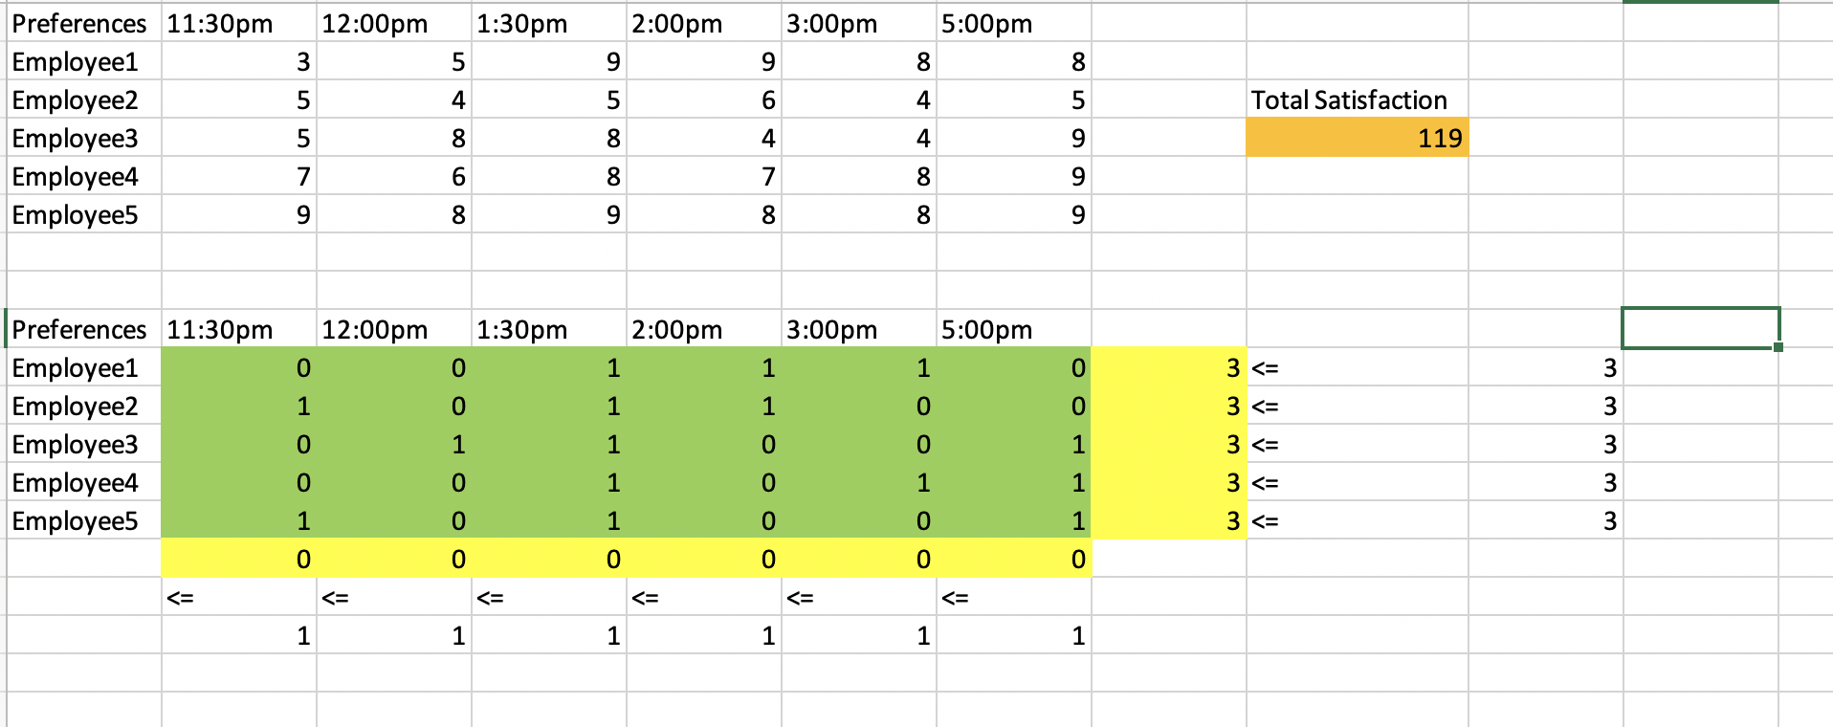

Based on the solver result, the maximize total satisfaction points equal 119.